

website proposal for the nelson branch of Olive growers new zealand

Web701 2016



March 4, 2016

TeamTeam2016

c.o. NMIT

Contents

Executive Summary 2

Introduction 2

User Requirements 2

General Functionality 2

Section – Specific Functionality 2

Site Goals 2

Mission or Purpose of the Organisation 2

Short Term Goals 2

Long Term Goals 2

Intended Audience 2

Attraction to the Website 2

Section Two – User Experience 3

Audience Definition 3

Scenarios 3

Competitive Analysis Summary 3

Section Three Site Content 3

Content Grouping and Labelling 3

Functional Requirements 3

Section 4 Site Structure 3

Site Structure Listing 3

Architectural Blueprints 3

Section 5 – Visual Design 3

Layout Grids 3

# Executive Summary

This report will present to you as our client a document that illustrates the creation of a website to promote Olive Oil Growers in the Nelson Region. I present this report as a set of recommended steps that are well documented in the web design industry as a template for creating you an effective and functional website. The goal is that you now have a prototype website that is aimed at your intended audience.

We recommend using a specific set of web technologies to help build the website such as the use of WordPress as on online content management system. This means that you will be able to customizable and edit your site should you wish to. Initially this will be set up by myself as a web developers but once the site is up and running you will be able to add and edit pages without needing to access the underlying web code.

The working website can be found at:

<http://bigears2.com/~corbin/wordpress/>

# Introduction

This report is presented to you as a document to help you understand the importance of having a functional website created using a system called WordPress. WordPress offers you the ability to pick from literally hundreds of different visual styles and themes and can be modified to suit your specifications.

From discussions with you as well as the documentation provided to our team we have prepared this report following to an industry standard known as Information Architecture. It is recommended best practice that will help you as well as us as your web development team in creating a website that helps to promote the values and goals of the Nelson branch of Olive Growers New Zealand.

There are specific sections of this report that focus on areas required of the site as well as who we feel are potential visitors to the site; from the general public researching about quality olive oil through to commercial restaurateurs wanting to purchase top quality oils for their restaurants.

# User Requirements

## General Functionality

We think that a functional website for you would contain a mixture of striking images, graphics, video and text that help to promote the Nelson branch of Olive Growers. These together would help the website to act as a central hub for all of the growers and help direct visitors to areas on the site that are of interest to them.

## Section – Specific Functionality

For example specific site pages could be about:

1. The benefits of olive oil & information on quality oils (not rancid (sold in supermarkets), diluted, mislabelled (things to look for). An informational graphic maybe?
2. The olive oil certification process and its importance in choosing quality oils.
3. Awards won by Nelson growers as well as the awards process, what certification stickers are and who have won medals
4. The different varieties of Olives
5. A list of all Nelson region olive groves and external links to their respective websites to purchase their oil

# Site Goals

## Mission or Purpose of the Organisation

The purpose of the new website is to increase the market share of Nelson Olive Growers and to educate the public on the many uses of olive oil including its many health benefits. We would also like to highlight the Nelson regions Olive Growers awards as well as illustrating and highlighting how quality olive oil is certified.

## Short Term Goals

A short term goal for the site is to produce a prototype mock-up of a website for Nelson Olive Growers New Zealand (NOGNZ). The short term goal is to provide a functional website that is active and will help benefit the organisation.

## Long Term Goals

To promote the organisation (NOGNZ) as well as having a central hub for visitors to find out about all of the Nelson region olive growers. This could also include a place for people to purchase local oil.

A registration and membership portion of the site to enable visitors to become involved with NOGNZ.

## Intended Audience

We believe that these would be the kinds of people that would visit your site (in no particular order):

1. The general public – people who like to use the oil for cooking or eating and/or who want to buy high quality and healthy olive oil.
2. Restaurateurs (to purchase top quality oil)
3. Health conscious people
4. Chefs (including celebrity chefs) for cooking / tasting purposes
5. Local and Regional Customers 🡪 Restaurants & their mangers
6. The media / press – buy New Zealand made. Buy local, buy organic, etc.
7. Local government – to promote the region and its quality olive oil growers.

## Attraction to the Website

To promote the new website we recommend utilising the following technological components such as:

1. Google search engine optimisation (SEO) – this can be provided as a paid service external to our services (via Google). This is beneficial to help direct people searching for Olive Oil to find your website from an online search engine like Google.
2. Online advertising – NZ Herald, Stuff, Nelson Mail, Local Mail campaign.
3. A social media campaign incorporating Facebook, Twitter.

In tandem to this you may also benefit from organising some of the following:

1. Promotional campaigns – tasting events, associations with Wine & Food events for example.
2. Discounts off products.
3. Competitions (win a sample pack / visit our site and enter the draw).

# Section Two – User Experience

## Audience Definition

We believe that there are many different types of users who would visit the site. These have been previously listed above under the Intended Audience heading.

Below are some typical scenarios that help to describe their common reasons for wanting to visit the site.

## Scenarios

A person wanting to buy a particular oil from this site!

Joe is a local Nelsonian living in the area for the past 10 years with her family, she tries to use the best quality ingredients she can for her family, especially her children. She strives to use locally grown foods to guarantee that the product has been made properly and to support the community. Joe is searching for Olive Oil to purchase in the Nelson region and is looking for information regarding how it’s made, where abouts specifically and which type of Olive Oil would best suit herself and her family.

Roger is a local chef in one of Nelson's most prestigious restaurants. To ensure quality of his food in his kitchen he strives to buy locally made products. Roger is looking to buy a new brand of Olive Oil to be used in his kitchen and is interested only in buying locally. He needs to know prices, packaging and how each Olive Oil is made so he can decide which is best for him. Roger would also like to contact the growers/suppliers of the Olive Oil so he can buy bulk for the restaurant.

Sara owns a local retail store in Nelson. She wants to start stocking locally made Olive Oils for her store. Sara needs to know everything there is about each brand of Olive Oil and would like to be in contact with the grower/supplier.

## Competitive Analysis Summary

Here are some link to sites; nationally and internationally that help promote Olive Oil.

<http://www.olivesnz.org.nz/>

<http://winenelson.co.nz/#home-welcome>

<http://www.olivesnz.org.nz/>

<http://nyoliveoil.com/>

<http://www.australianolives.com.au/>

Below are screenshots from some of these sites for your reference:

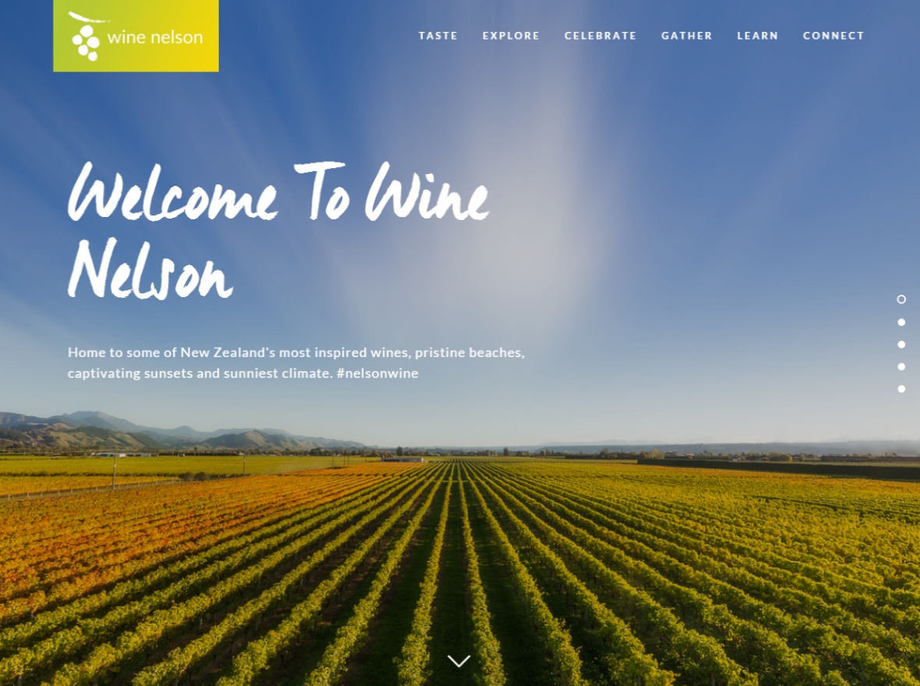

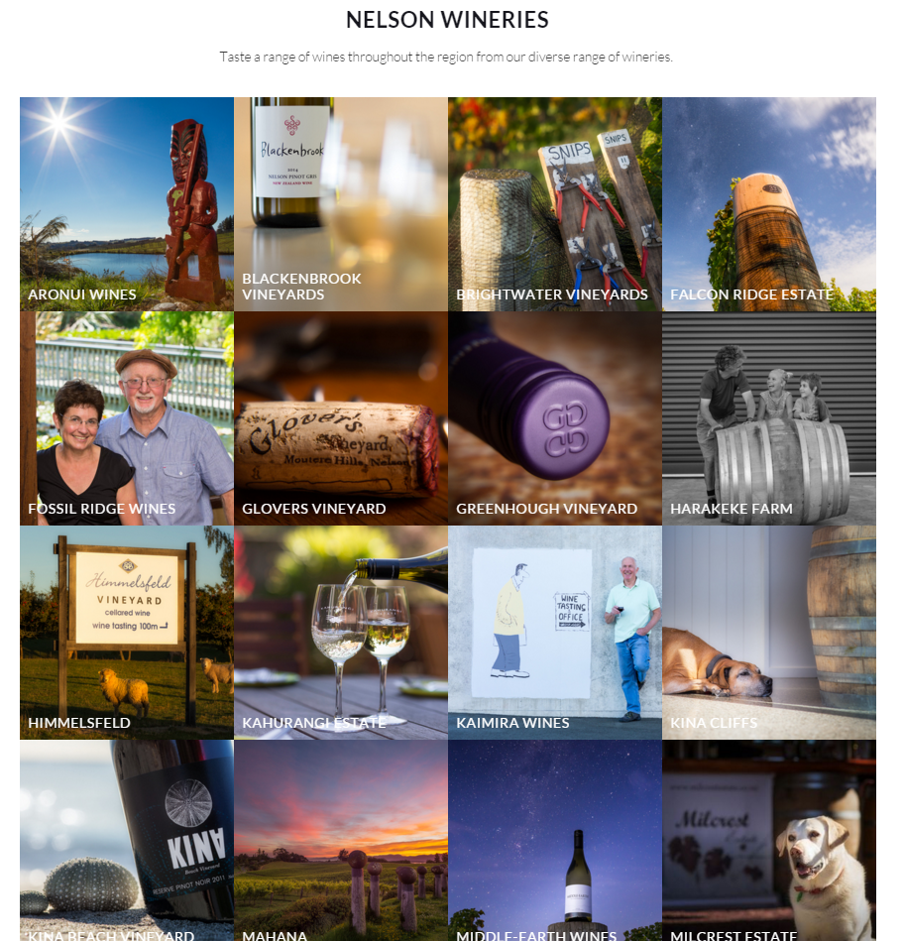

This is how they illustrate the wine growers in Nelson.

### Olives New Zealand

Great website for information about NZ Olive Oil

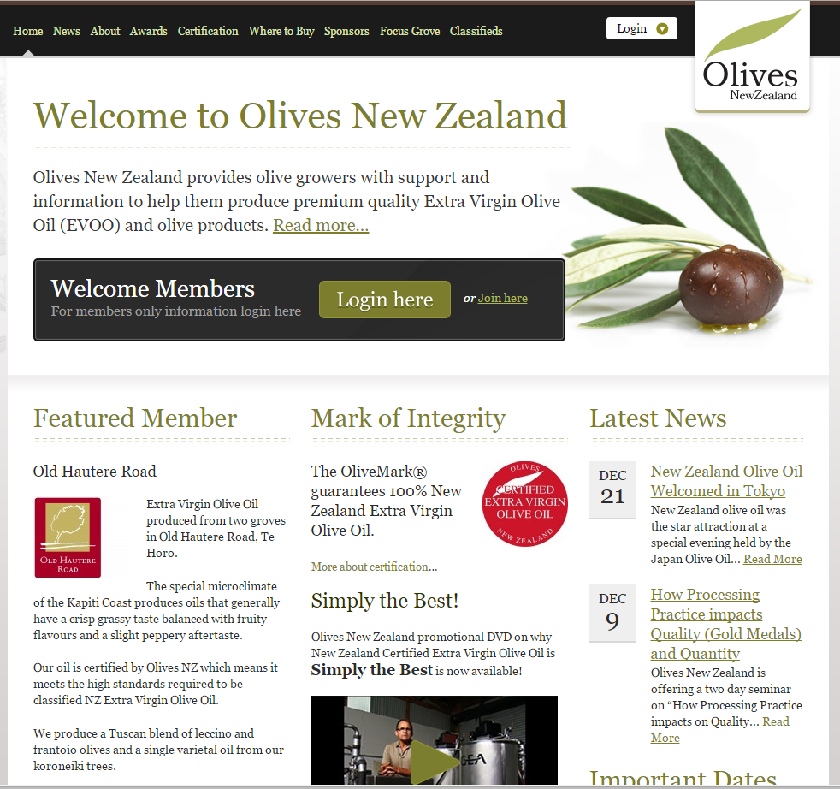



A good navigation bar with links to specific areas of interest

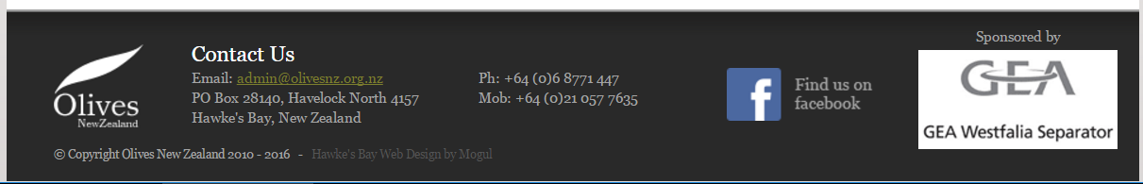

This is the footer. Good contact information and link to Facebook page. Also note a sponsorship link.

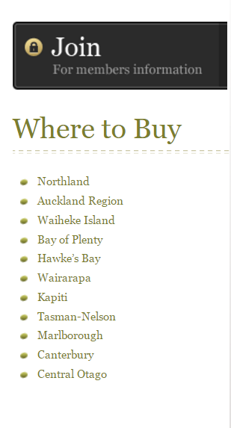

The sidebar of Olives NZ. Note regional links and where to buy.

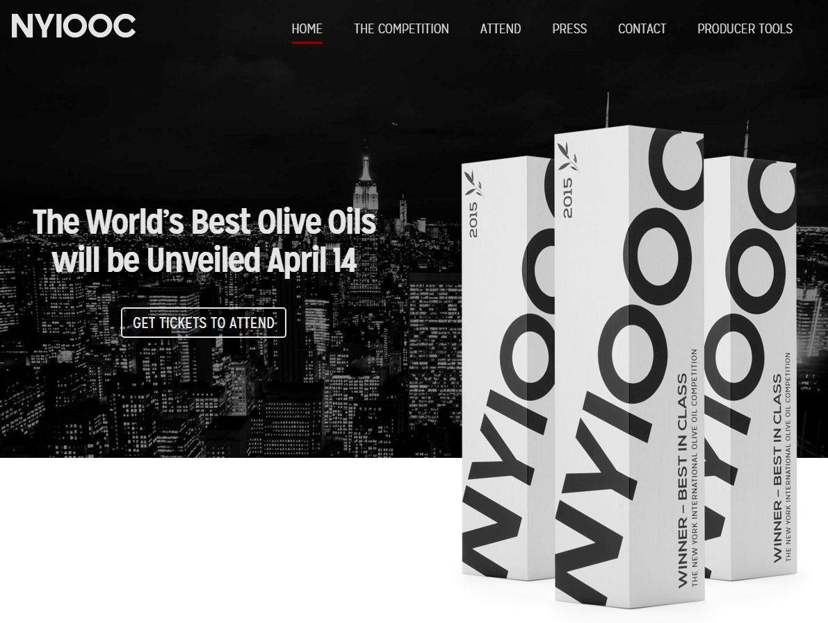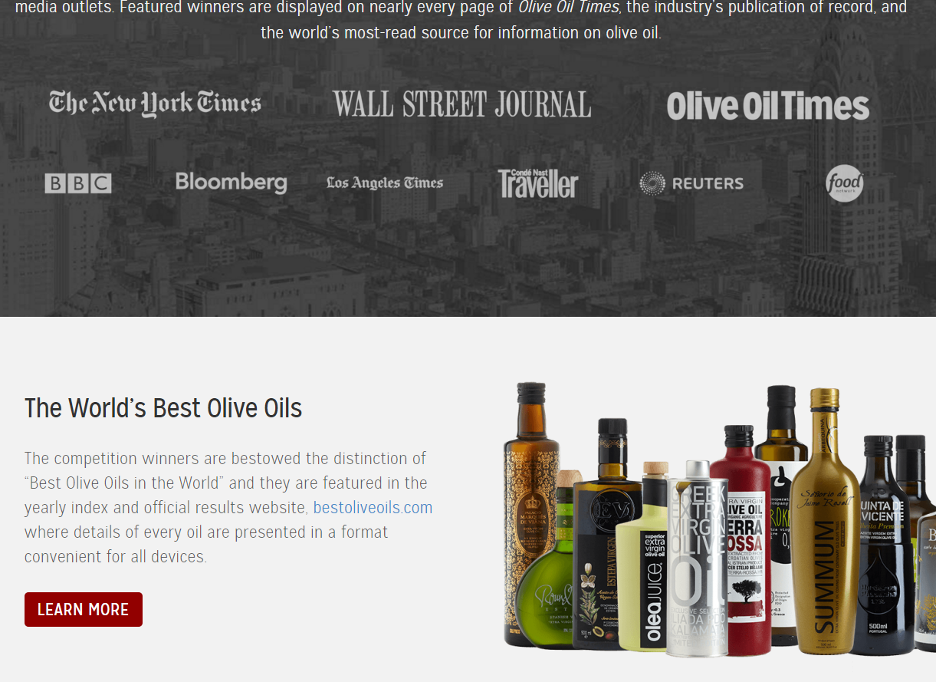

Very aggressively marketed site. Very professional and “New York” Nice images but maybe not necessarily what is wanted for Nelson region?

The Australian competition (<http://www.australianolives.com.au/>)<http://www.australianolives.com.au/>)

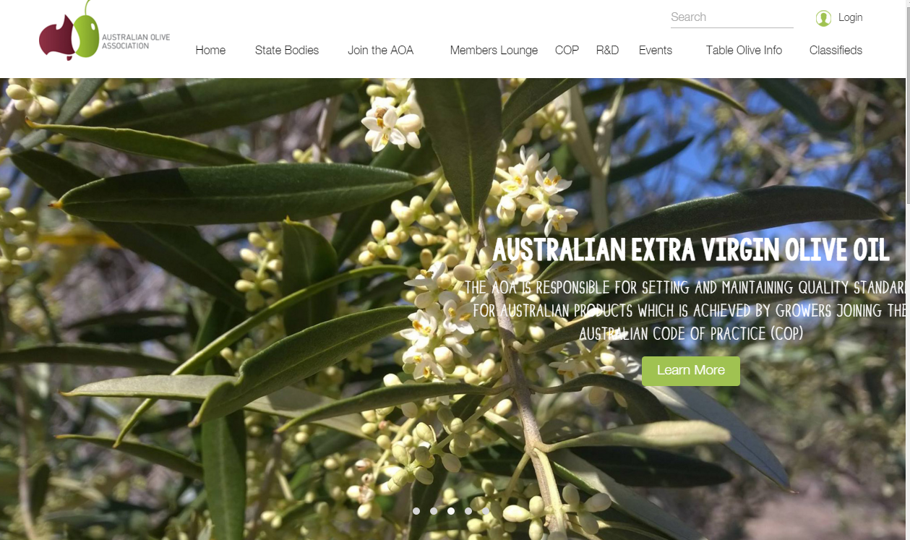

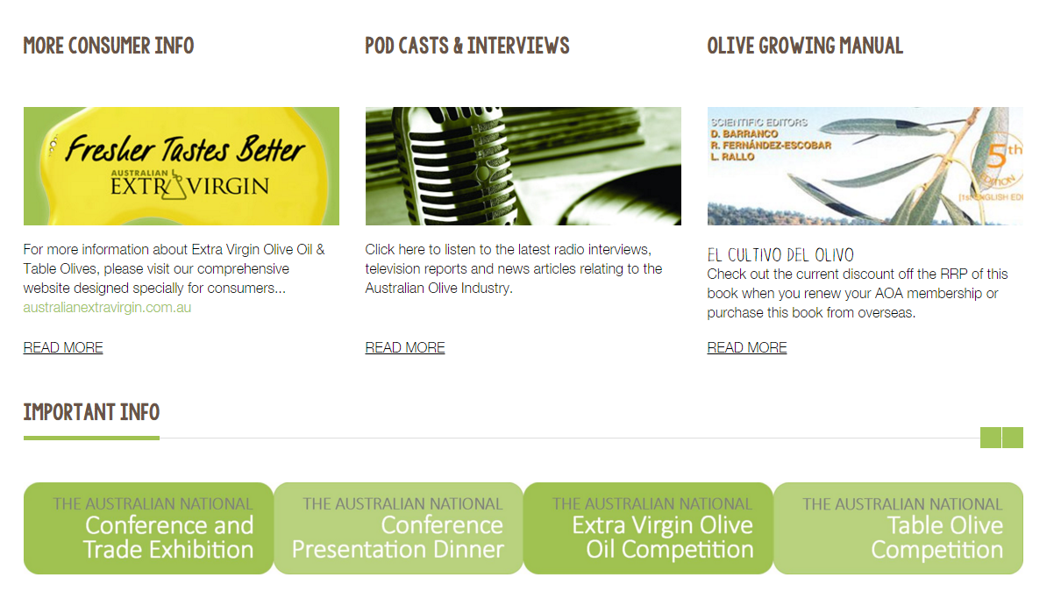

The bottom of the main page. Nice bright colours. (Maybe too bright?).

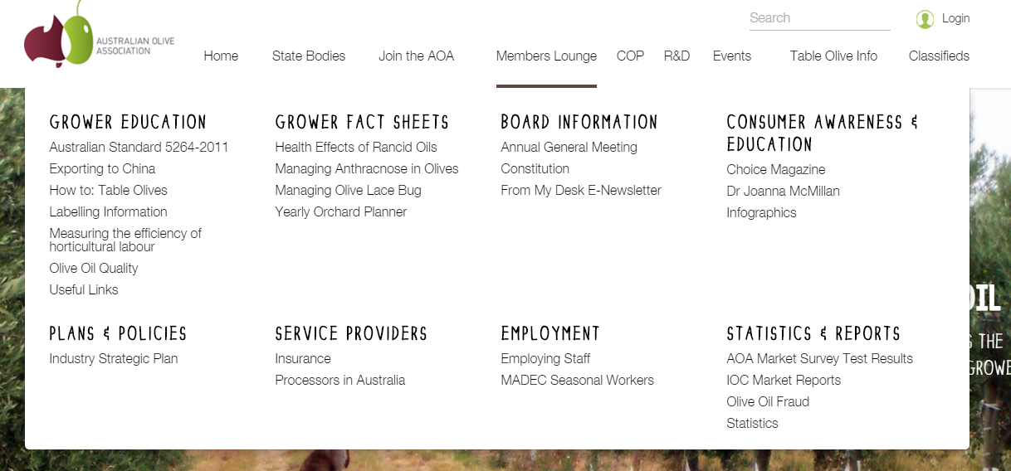

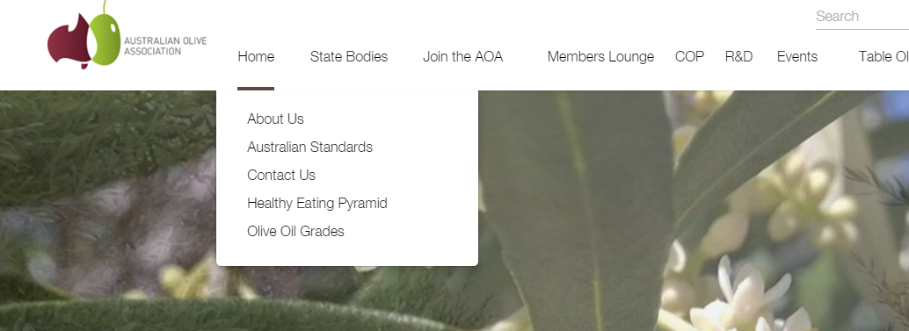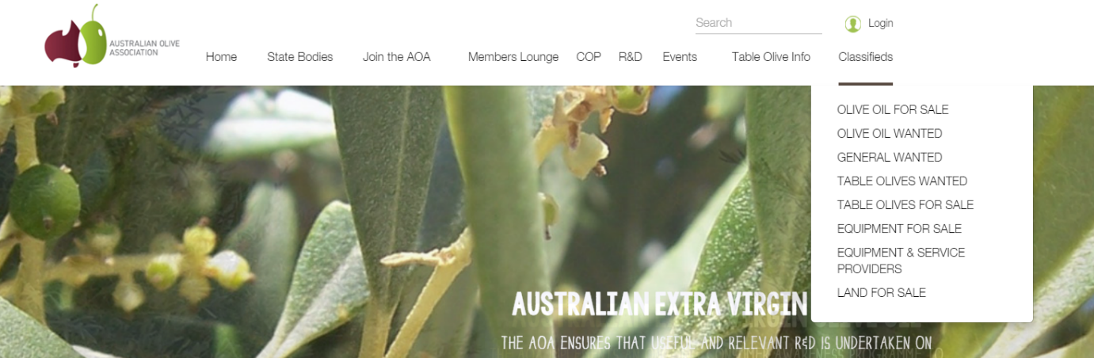

Their site contains a large YouTube video on the main page as well as

# Section Three Site Content

## Content Grouping and Labelling

With the above content requirements in mind, we have divided the content into the pages below:

1)   *Home*

o   Static general Introduction to Olive New Zealand and its Nelson branch.

o   Dynamic content about upcoming events in the Olive area, if any.

2)   *About Olives*

o   Static general information about olive oil, its uses, and its benefits.

o   Static general information about the olive oil production process, highlighting any special techniques used by Nelson based groves.

3)   *About / Contact Olive New Zealand*

o   Dynamic contact information for Olive New Zealand in general, with links to other sites.

4)   *About / Contact Our Nelson Members*

o   Dynamic content about each registered Nelson grove, their products, and their contact information.

These are the pages I propose for the site, utilizing the static, functional, dynamic, and transactional content as outlined above. This site setup leaves one content requirement out, which is;

-          Transactional content allowing visitors to sign up for a newsletter, if any.

The reason this is left out is that I think it should be built directly into the footer of the website, which would not change depending on page, and remain the same over any page on the website. If the footer is block coloured and attractive, it would serve well.

## Functional Requirements

Functionally the website is primary designed to be a place to advertise and focus on the Nelson and the Olive Oil Growers in this region.

The website will be set up so that each grove has a distinct page to advertise from as well as other pages like a newsletter section on the site for local, regional and international news should the stakeholders decide.

We are not going to add any functional things such as google maps as this was not required by the stakeholders in their brief (as they do not want visitors to their groves).

The ability to purchase olive oil will be handled separately by each individual grove therefore we have included links to each grove’s contact or sales page should a visitor wish to purchase the olive oil directly.

Some non-functional requirements of the site would be to include the ability of grove owners to access the site should they wish to change their respective information pages or add new content to the site. This is available through a plugin added to WordPress to enable different users with an email and login details to only edit specific pages on the site.

## Metaphors

## **Metaphor Exploration – Functional Metaphor**

Functional metaphors relate to tasks or things a visitor would undertake on the website, to things that can be done elsewhere;

-          Our site can be compared to a phone book for Nelson Olive groves, but instead of just locational and contact information, we provide images and descriptions. A visitor / user can look up different groves in the Nelson / Tasman region

The only problem with this metaphor is our site is like an ‘exclusive’ phonebook, where you can only be registered in the collection if you are a member of Olive NZ.

## **Metaphor Exploration – Visual Metaphor**

Visual metaphors relate common graphics elements on your site to others familiar out in the world.

# Section 4 Site Structure

## Site Structure Listing

Navigation for the site will be fairly simple, and we suggest using the same sort of style as is used on [winenelson.co.nz](http://winenelson.co.nz/), a site that was mentioned as a good candidate by the major stakeholder.

-          On the left there is a logo, which is also a link back to the homepage of the site.

-          On the right there are three more links to pages on the website, as follows;

o   The page about Olive Oil, its uses and benefits.

o   The page about Nelson Groves, with a carousel, and contact information

o   The page about Olive NZ, with contact information

-          On all pages, a vertical slider of some form allowing the visitor to track how far down a page they are, or to jump right to a section. Much like the Nelson Wine page again.

## Sitemap

Here is our idea of a sitemap of the site:

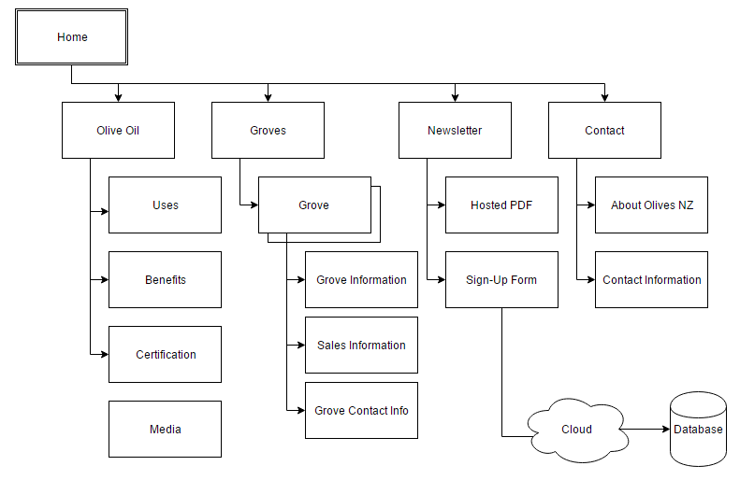

# Section 5 – Visual Design

## Layout Grids

These are mock up grids used to visually describe the web pages.

Here is a layout grid of our proposed front-page for the website:

## Main Page Layout

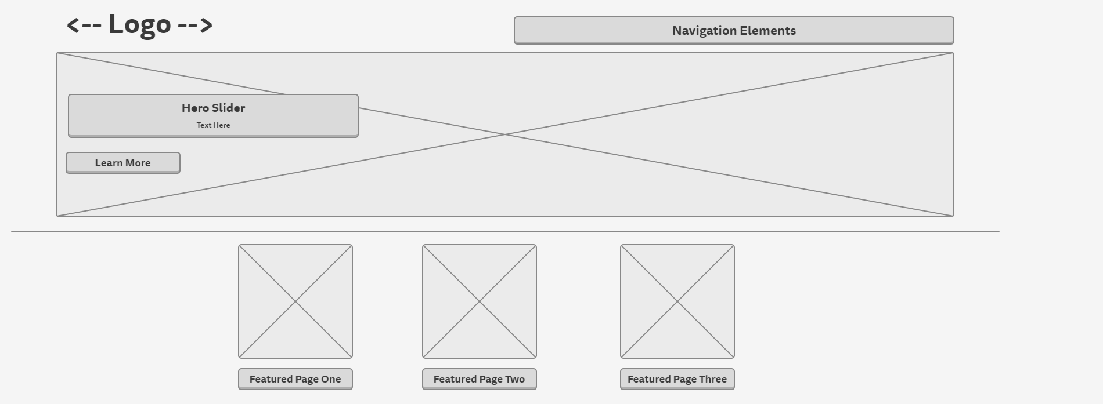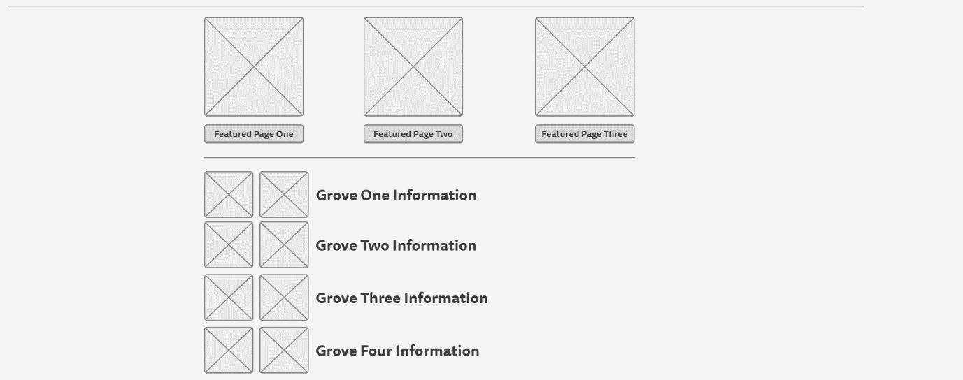

In our prototype site we have used placeholder images and icons to represent an effective theme of Olive Oil.

Below is a visual representation of the above wireframe:

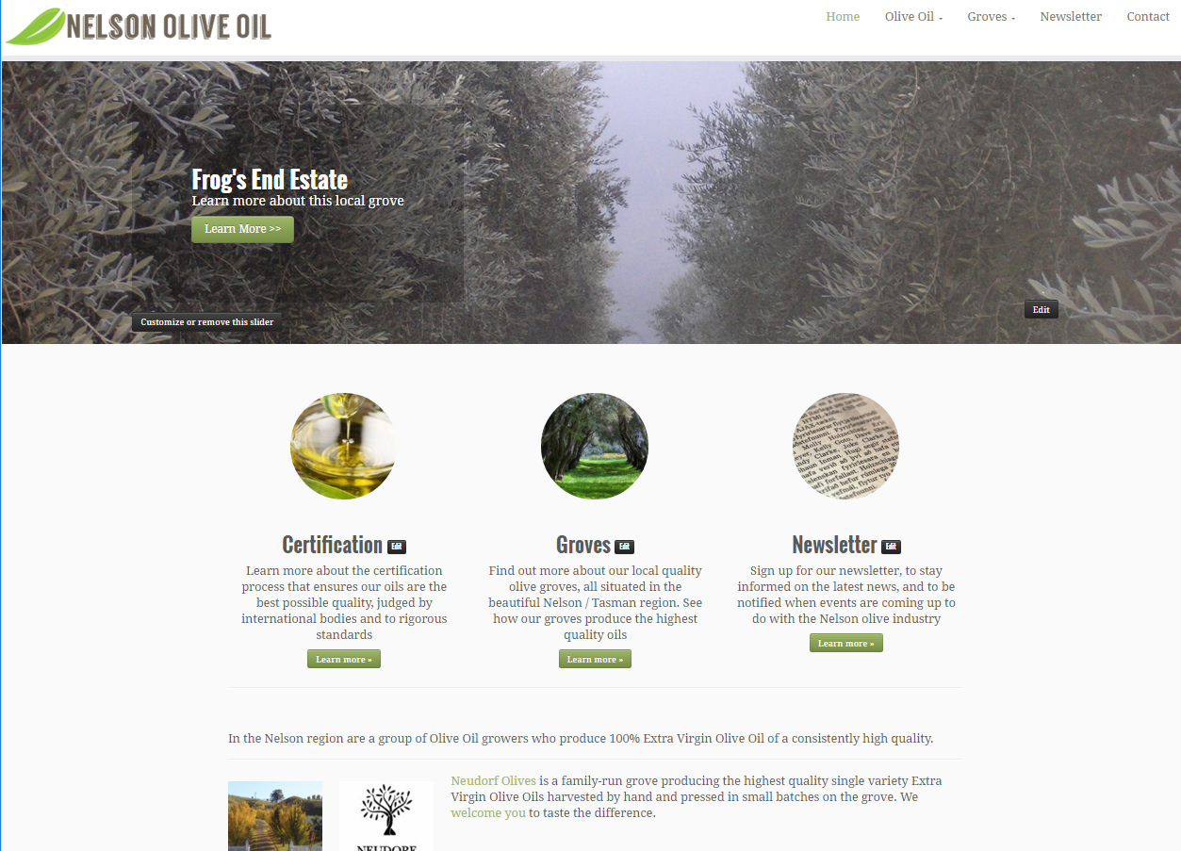

## Individual Grove Page Layout

## 

## 

## Contact Page Layout

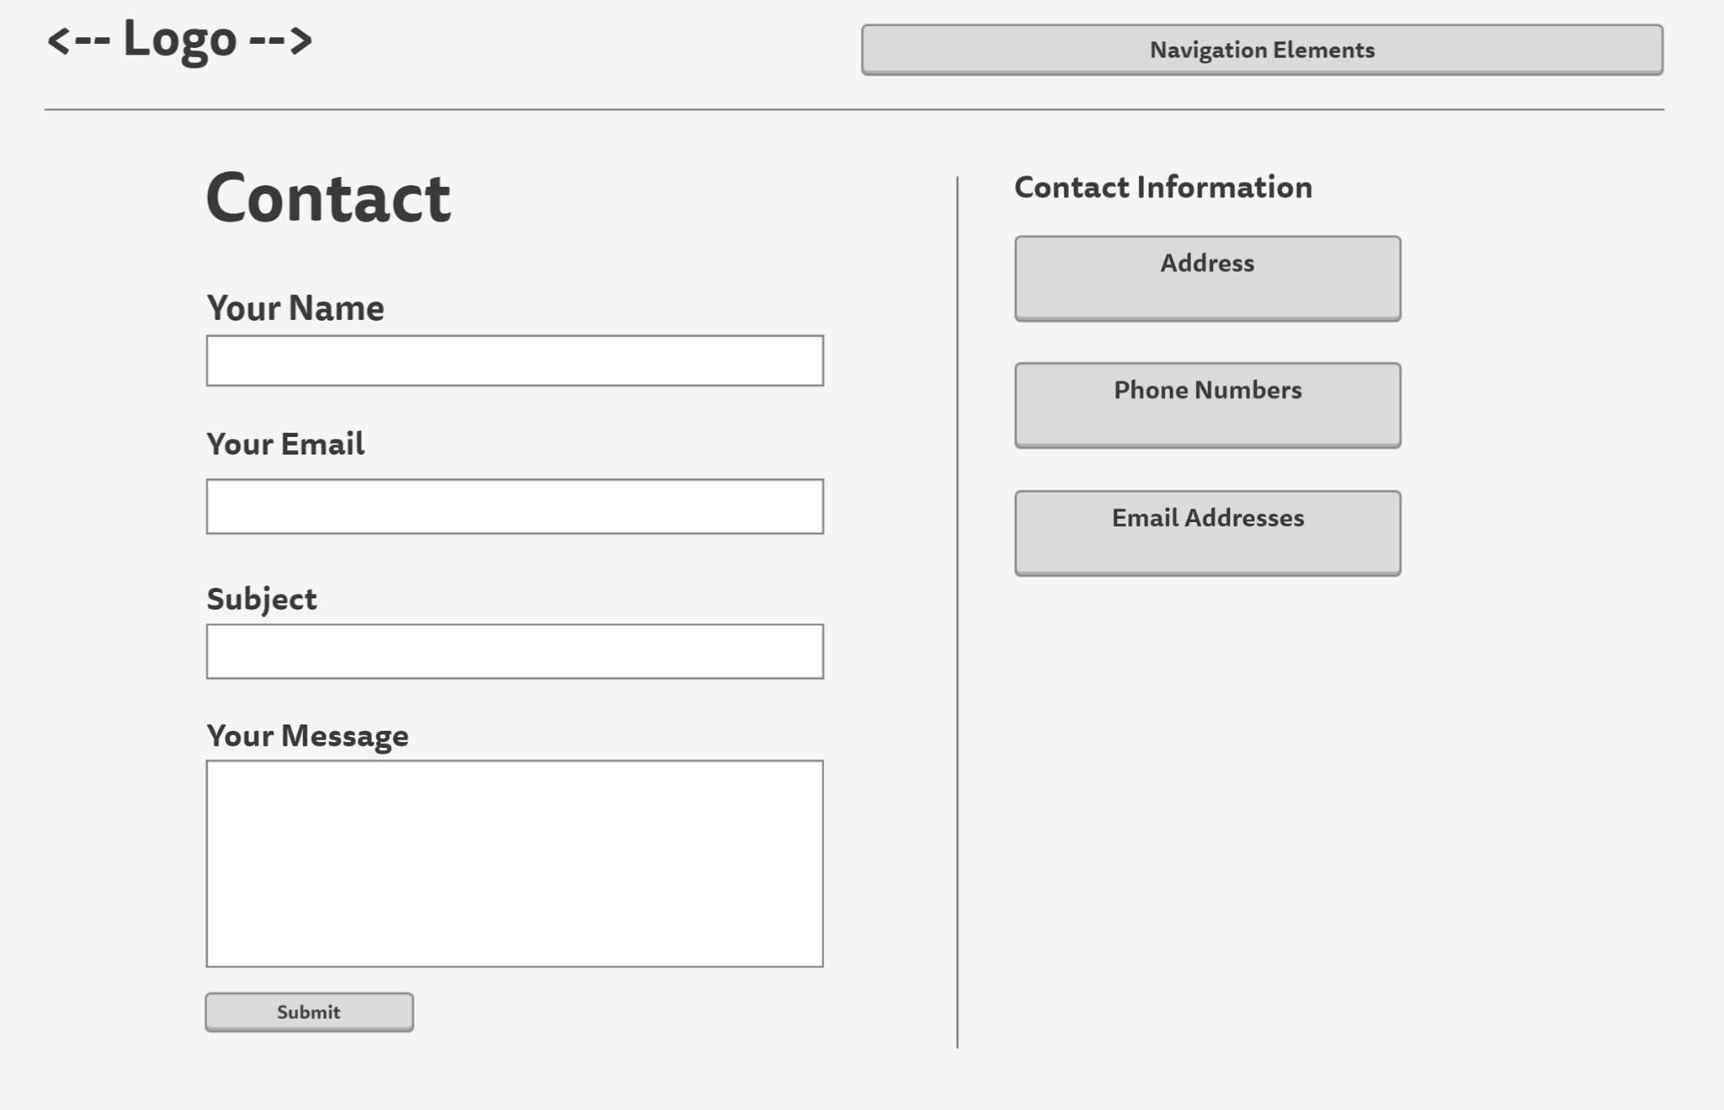

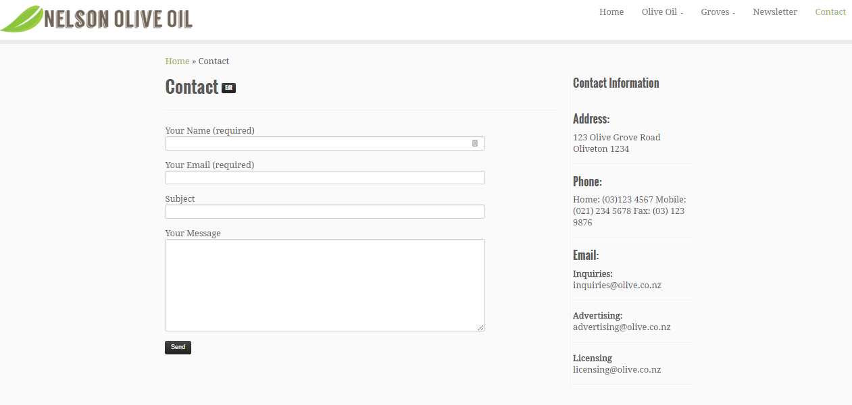

# Conclusion

This report has described how I have used a formal design process to develop and build a functional website for you as the Nelson Olive Branch of Olive Oil Growers.

I have detailed how this could be used to go forward and be used as a live website for your Olive Oil growers in the Nelson Region.